BUG REPORT

* + #01 [Create Account] Displaying wrong error message

**Environment :**

Device : Lenovo Laptop

OS : Windows 8

Browser : Chrome Version 57.0.2987.110 (64-bit)

**Types of Severity:** Medium

**Steps to Reproduce:**

1. Navigate to <http://automationpractice.com/>
2. Click ‘Sign in’ Button
3. Enter appropriate email that want to register in ’email address’ field
4. Click ‘Create an Account’ Button
5. Choose country value “-”
6. Click Button Register

**Expected Result** : Error message should be displayed for invalid country

**Actual Result :** Displaying error message “Country cannot be loaded with address->id_country and required id_country” database field might not been shown on error message

**Attachment:**

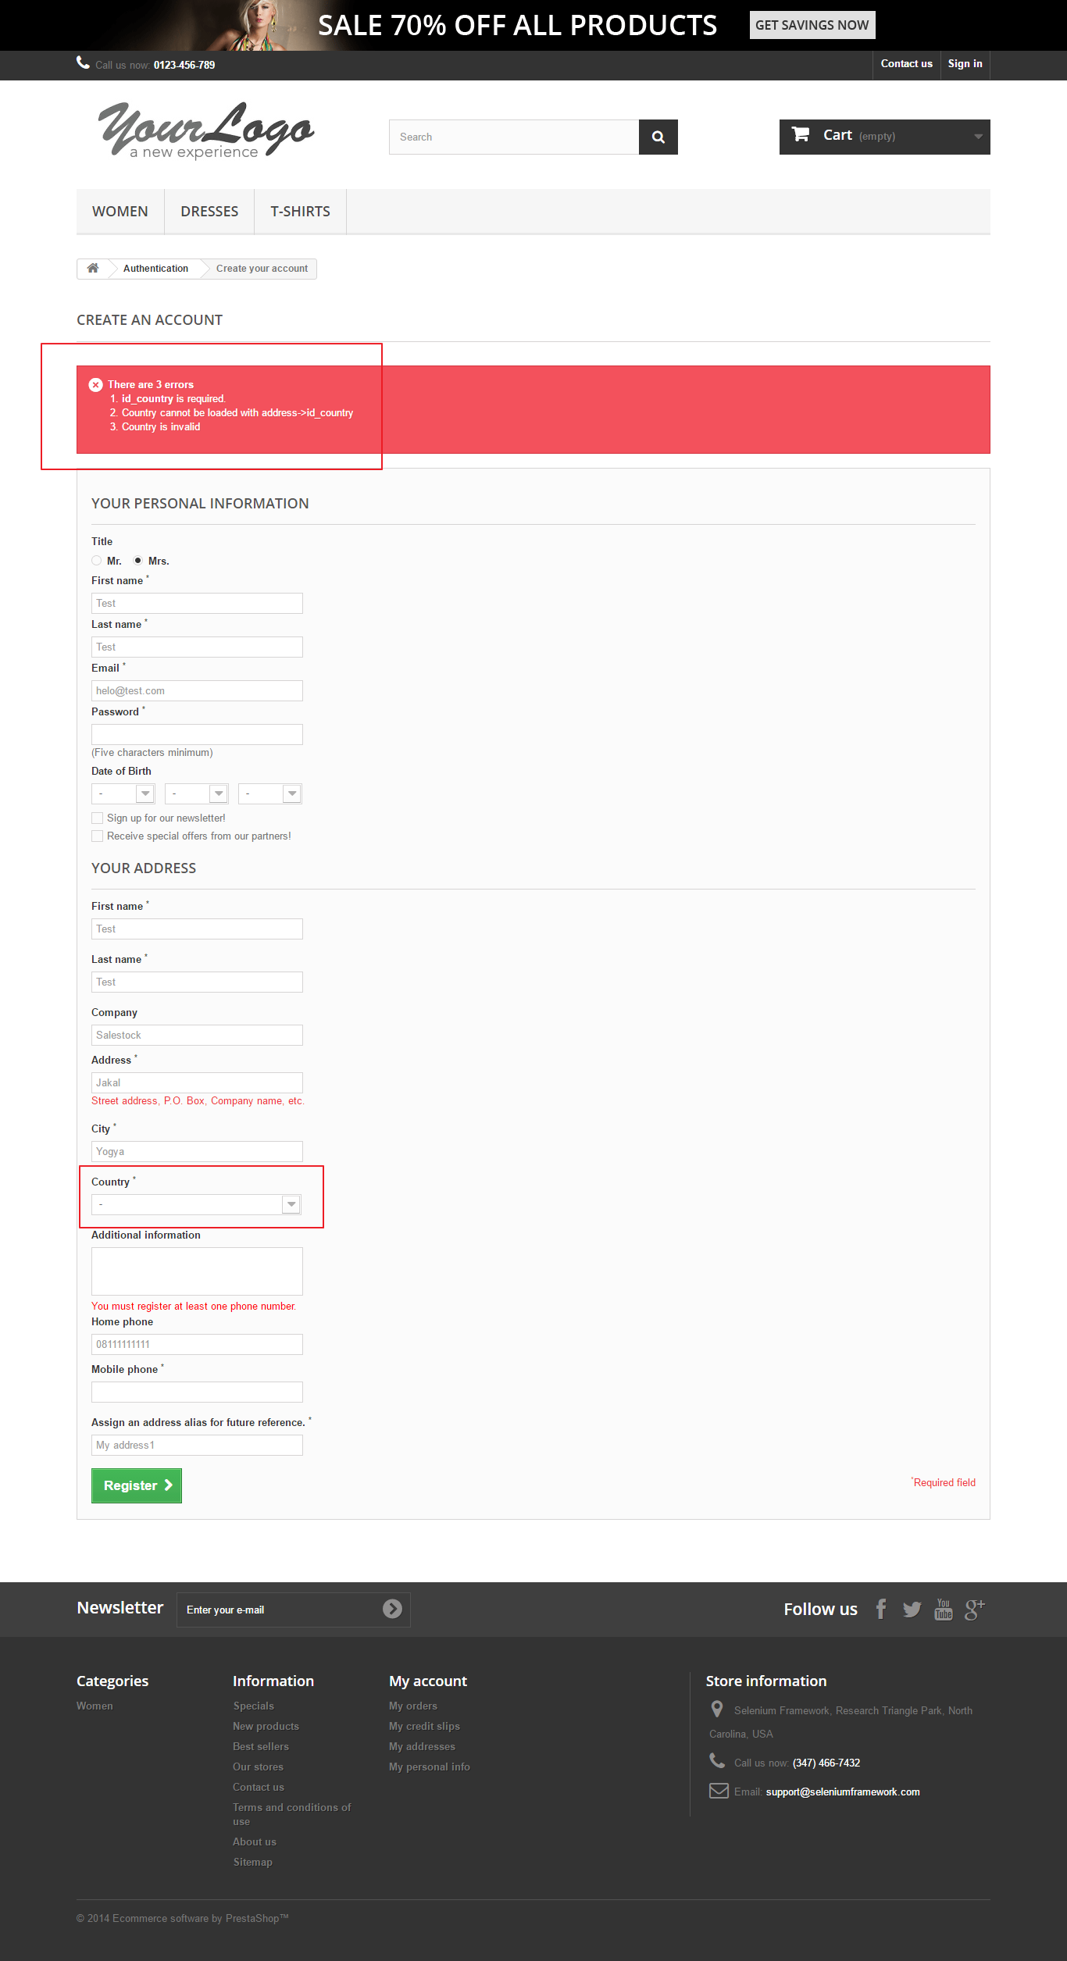

* + #02 [Create Account] Displaying confusing error message

**Environment :**

Device : Lenovo Laptop

OS : Windows 8

Browser : Chrome Version 57.0.2987.110 (64-bit)

**Types of Severity:** Medium

**Steps to Reproduce:**

1. Navigate to <http://automationpractice.com/>
2. Click ‘Sign in’ Button
3. Enter appropriate email that want to register in ’email address’ field
4. Click ‘Create an Account’ Button
5. Input value :

* empty/wrong format Zip Postal code Data
* Others : valid and not empty

1. Click Button Register

**Expected Result** : Error message should be displayed for zip/postal code data

**Actual Result :** Error message make user confused because the instruction is not clear.

Error message that has been found:“It must follow this format: 00000”

**Attachment:**

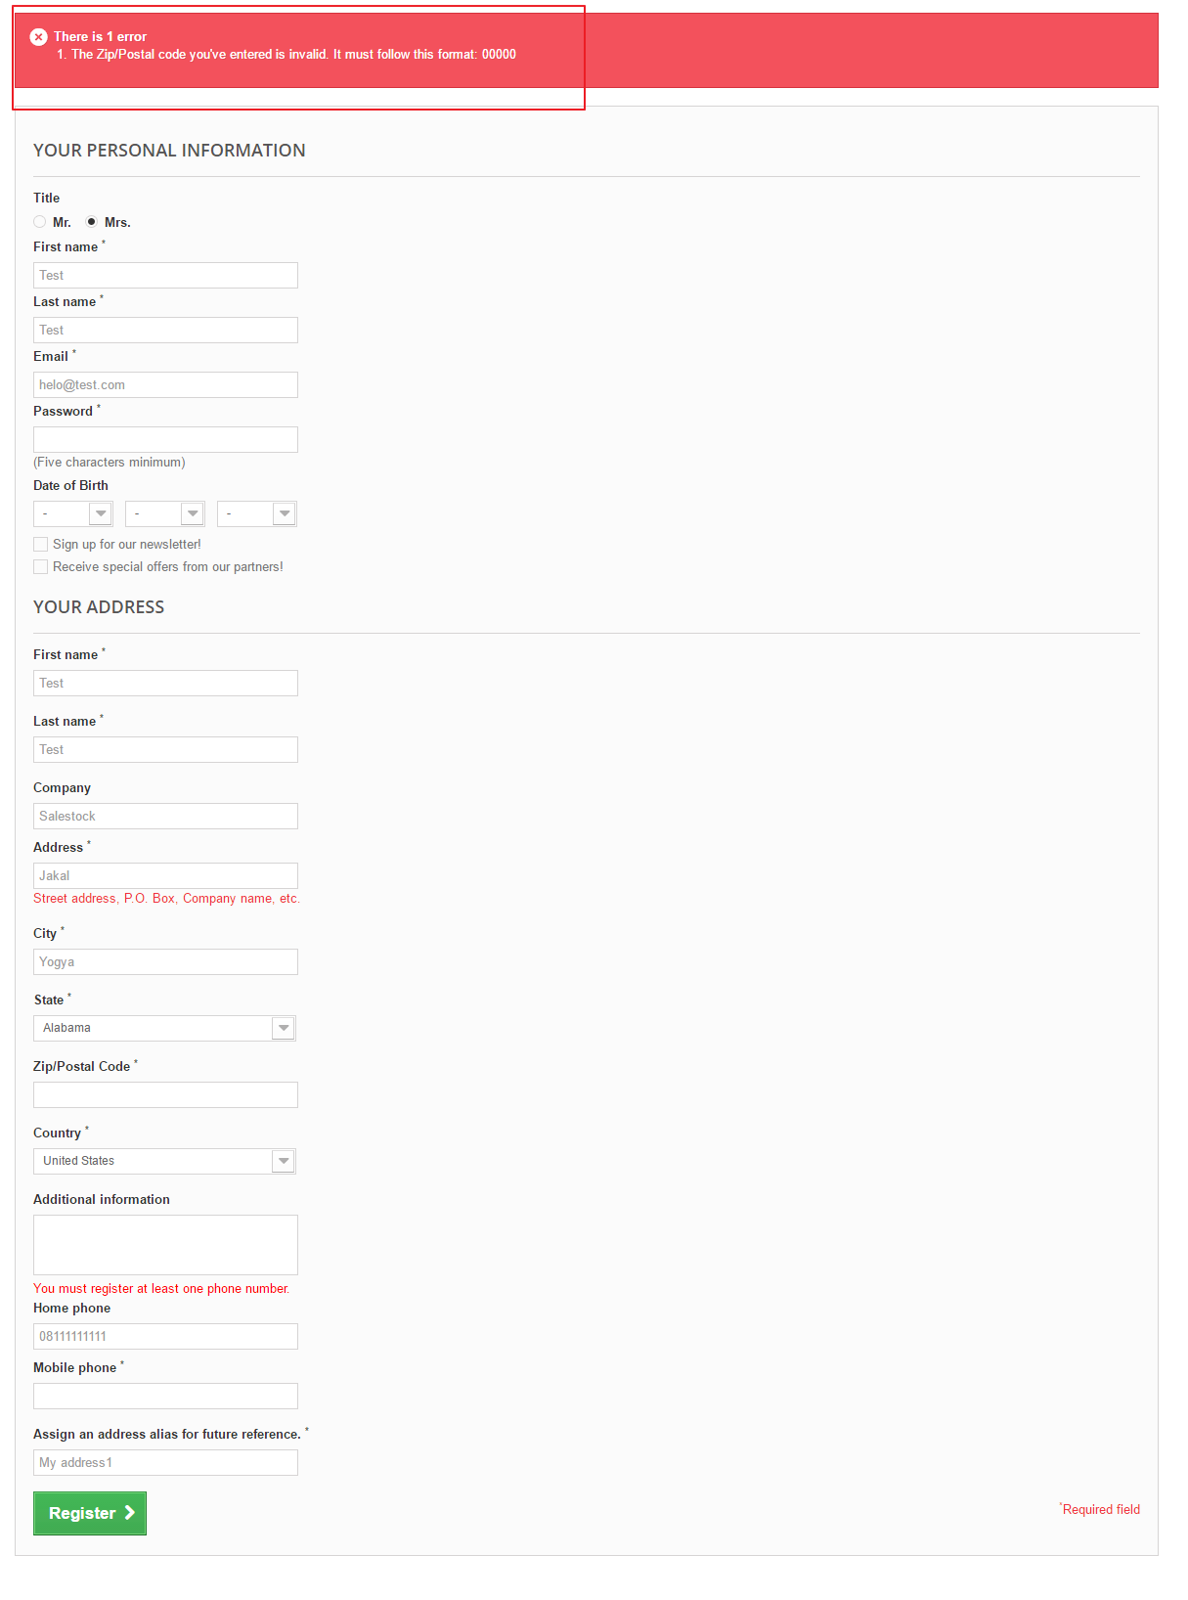

* + #03 [Create Account] Able to go to previous page and submit same data after registering new user.

**Environment :**

Device : Lenovo Laptop

OS : Windows 8

Browser : Chrome Version 57.0.2987.110 (64-bit)

**Types of Severity:** Major

**Steps to Reproduce:**

1. Navigate to <http://automationpractice.com/>
2. Click ‘Sign in’ Button
3. Enter appropriate email that want to register in ’email address’ field
4. Click ‘Create an Account’ Button
5. Input value:

All data valid and not empty

1. Click Button Register

**Expected Result** : Register successful and redirect to MyAccount page

**Actual Result :** After submiting register form and redirect to My Account page, user might not be able to go to previous page, but in this case, user be able to go to previous page and submit register form with same data.

**Attachment**

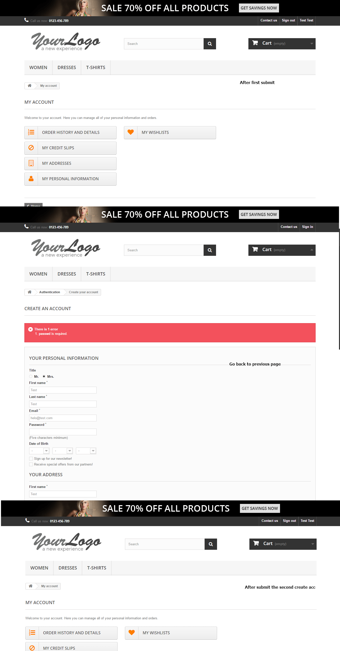

* + #04 [Edit Personal Data] Wrong error message on Password Field.

**Environment :**

Device : Lenovo Laptop

OS : Windows 8

Browser : Chrome Version 57.0.2987.110 (64-bit)

**Types of Severity:** Medium

**Steps to Reproduce:**

1. Navigate to <http://automationpractice.com/>
2. Login to the page
3. Navigate to My Account page
4. Click ‘My Personal Information’ Button
5. Input value :

- Empty current Password

- Other data valid

1. Click ‘Save’ Button

**Expected Result** : Error message should be displayed for required Password

**Actual Result :** Wrong error message. Error message that has been found : The password you entered is incorrect. Even though it was an empty data.

**Attachment**

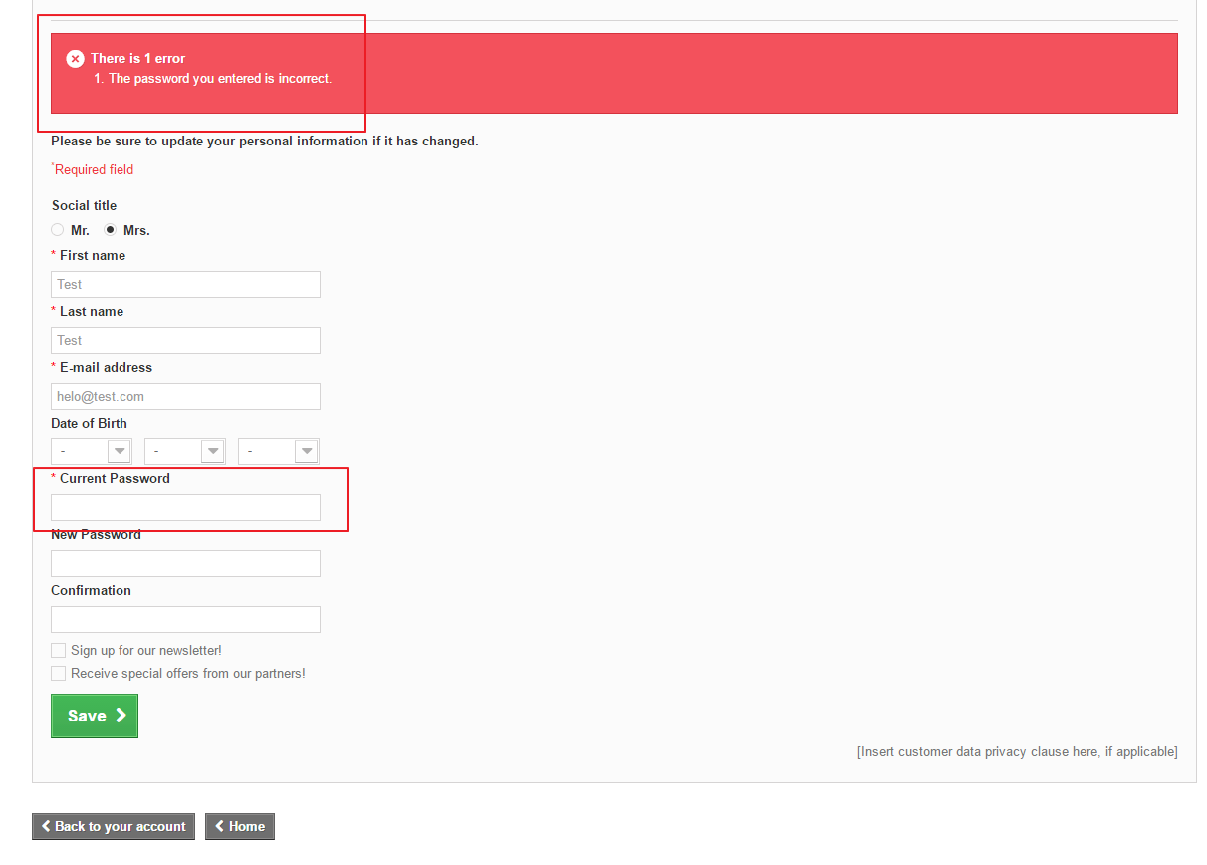

* + #05 [Edit Personal Data] No validation to handle same password between current and old password.

**Environment :**

Device : Lenovo Laptop

OS : Windows 8

Browser : Chrome Version 57.0.2987.110 (64-bit)

**Types of Severity:** Medium

**Steps to Reproduce:**

1. Navigate to <http://automationpractice.com/>
2. Login to the page
3. Navigate to My Account page
4. Click ‘My Personal Information’ Button
5. Input value :

- Same data between current password, new and confirmation password

- Other data valid

1. Click ‘Save’ Button

**Expected Result** : Error message/validation should be displayed for same password

**Actual Result :** Data is successfully updated. Update data means we put an another data less than existing data. But in this case, there is no error message to handle this issue

**Attachment**

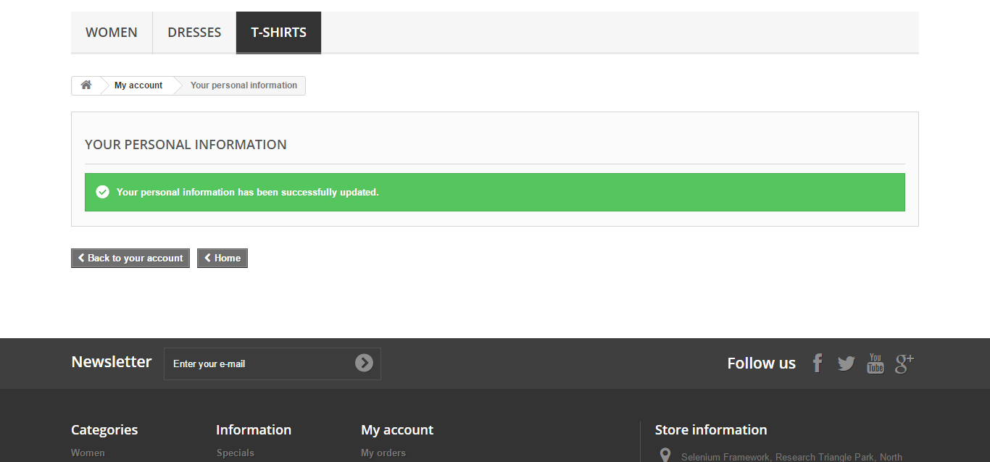

* + #06 [Forgot Password] No validation to handle same password between current and old password.

**Environment :**

Device : Lenovo Laptop

OS : Windows 8

Browser : Chrome Version 57.0.2987.110 (64-bit)

**Types of Severity:** Major

**Steps to Reproduce:**

1. Navigate to <http://automationpractice.com/>
2. Click ‘Forgot your password?’ link
3. Enter valid ‘Email address’
4. Click ‘Retrieve password’ Button
5. Verify new password has been sent to email address

**Expected Result** : New Password has been sent to email

**Actual Result :** New password has not been sent to email

**Attachment**

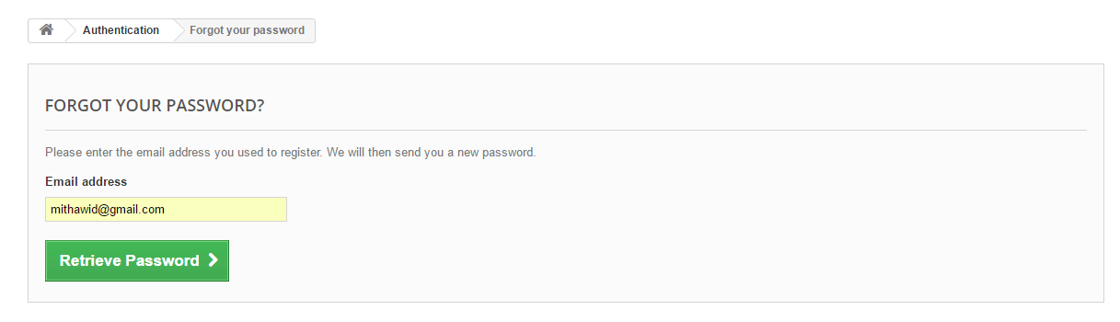

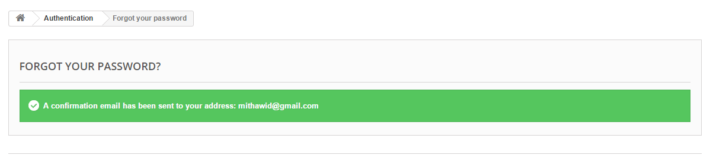

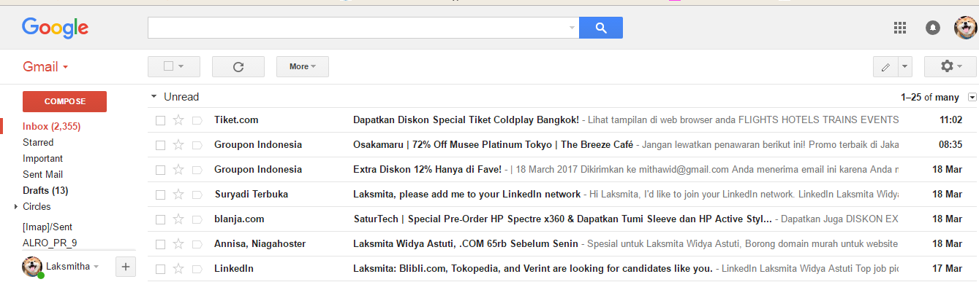

* + #07 [Update user Address] Displaying confusing error message

**Environment :**

Device : Lenovo Laptop

OS : Windows 8

Browser : Chrome Version 57.0.2987.110 (64-bit)

**Types of Severity:** Medium

**Steps to Reproduce:**

1. Navigate to http://automationpractice.com/
2. Login to the page
3. Navigate to My Account Page
4. Click ‘My Addresses’ Button
5. Click Update Address
6. Input value:

* Empty/wrong format Zip Postal code Data
* Others : Valid and not empty data

1. Click save button

**Expected Result** : Error message should be displayed for zip/postal code data

**Actual Result :** Error message make user confused because the instruction is not clear.

Error message that has been found:“It must follow this format: 00000”

**Attachment:**

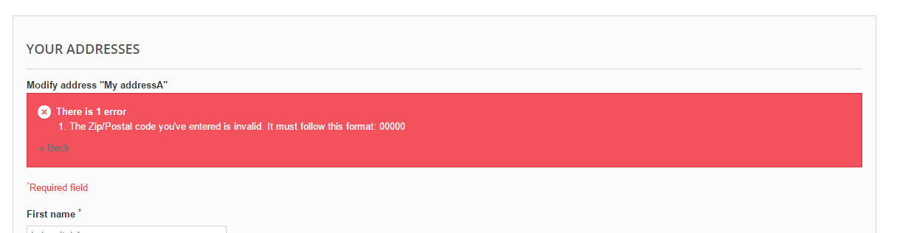

* + #08 [Add user Address] Displaying confusing error message

**Environment :**

Device : Lenovo Laptop

OS : Windows 8

Browser : Chrome Version 57.0.2987.110 (64-bit)

**Types of Severity:** Medium

**Steps to Reproduce:**

1. Navigate to http://automationpractice.com/
2. Login to the page
3. Navigate to My Account Page
4. Click ‘My Addresses’ Button
5. Click Add New Address
6. Input value:

* Empty/wrong format Zip Postal code Data
* Others : Valid and not empty data

1. Click save button

**Expected Result** : Error message should be displayed for zip/postal code data

**Actual Result :** Error message make user confused because the instruction is not clear.

Error message that has been found:“It must follow this format: 00000”

**Attachment:**

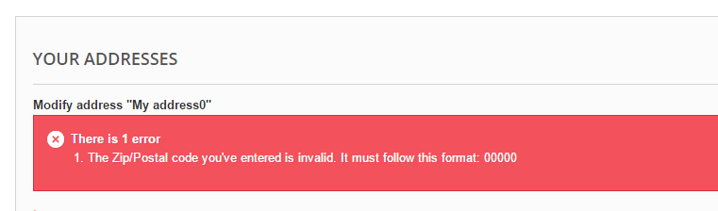

* + #09 [Manage order History] Problem on Expanding order history details

**Environment :**

Device : Lenovo Laptop

OS : Windows 8

Browser : Chrome Version 57.0.2987.110 (64-bit)

**Types of Severity:** Medium

**Steps to Reproduce:**

1. Navigate to <http://automationpractice.com/>
2. Login to the page
3. Navigate to My Account Page
4. Click Details Button

**Expected Result** : Page should be able to expand the detail order history

**Actual Result :**

* Click button details is slow to expand the page
* The page could not expanding out if user want to close the detail page.

**Attachment:**

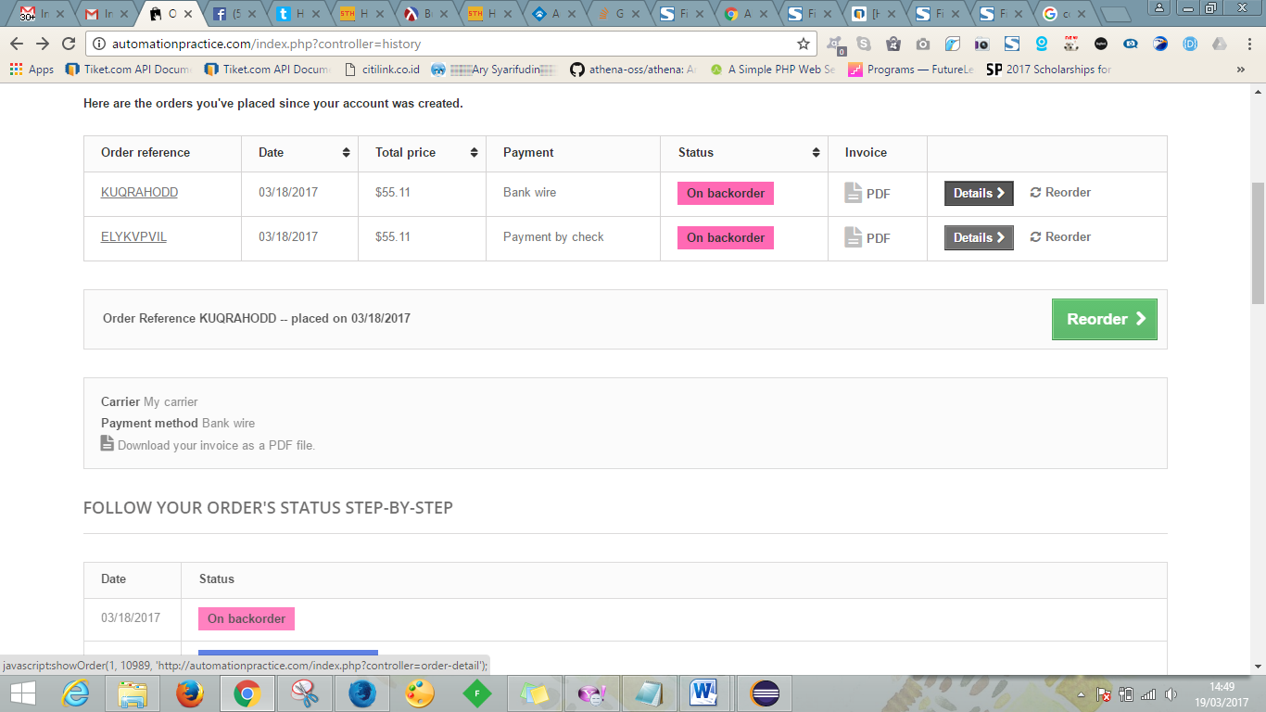

* + #10 [Search Autocomplete] Keyword does not match with suggestion that has been suggested by autocomplete

**Environment :**

Device : Lenovo Laptop

OS : Windows 8

Browser : Chrome Version 57.0.2987.110 (64-bit)

**Types of Severity:** High

**Steps to Reproduce:**

1. Navigate to <http://automationpractice.com/>
2. Navigate to search bar on homepage
3. Enter keyword on search bar:

Search field = “Dresses’

**Expected Result** : Show suggestion list related to keyword that has been sent

**Actual Result :** All products was shown in suggestion list even though does not contain ‘Dresses’ keyword

**Attachment:**

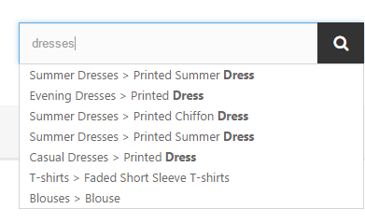

* + #11 [Filter and Sort Search Result] Data that have been sorted is not appropriate

**Environment :**

Device : Lenovo Laptop

OS : Windows 8

Browser : Chrome Version 57.0.2987.110 (64-bit)

**Types of Severity:** High

**Steps to Reproduce:**

1. Navigate to http://automationpractice.com/

2. Click one of categories on menu bar i.e : “Dresses” menu

**Expected Result** : Search result must be sorted accending according to sort menu that has been selected

**Actual Result :**

- Search results are not able to sorted by highest price

- Search results are not able to sorted by product name Z-A

- Search results are not able to sorted by reference: Highest first (there are no significant differences between reference on lowest first with highest first)

**Attachment:**

* Highest price



* Product name Z-A



* References High to low and Low to high (not change)

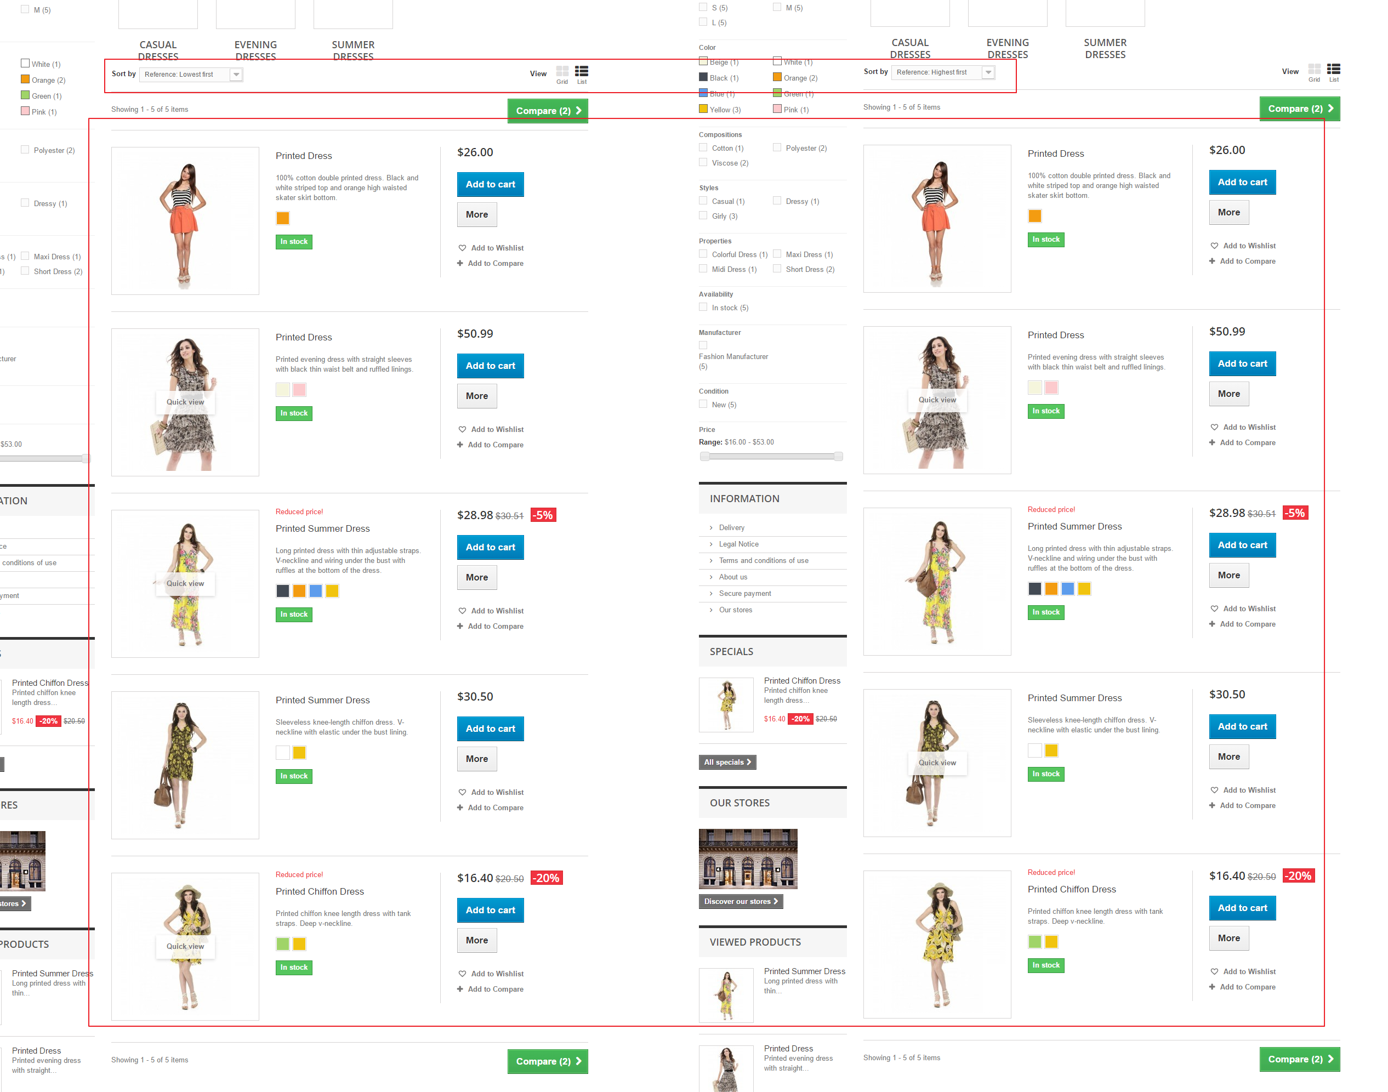

* + #12 [Compare to another products] Comparing product could not been shown in a certain number

**Environment :**

Device : Lenovo Laptop

OS : Windows 8

Browser : Chrome Version 57.0.2987.110 (64-bit)

**Types of Severity:** High

**Steps to Reproduce:**

1. Navigate to http://automationpractice.com/

2. Click one of categories on menu bar i.e : “Dresses” menu

3. Hover one of the product

4. Click Add to compare button using various input value:

* Three or odd times in different product
* Even times but more than four

5. Click Compare button

**Expected Result** : Redirect to compare page and comparing on a certain amounts

**Actual Result :**

* Redirect to compare page and just show 1 product to compare if using three or odd times in different product input
* Redirect to compare page and just comparing 2 different products using even times but more than four input

**Attachment:**

* Comparing 3 products

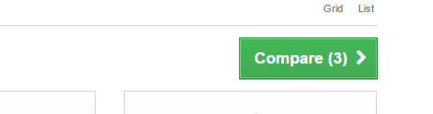

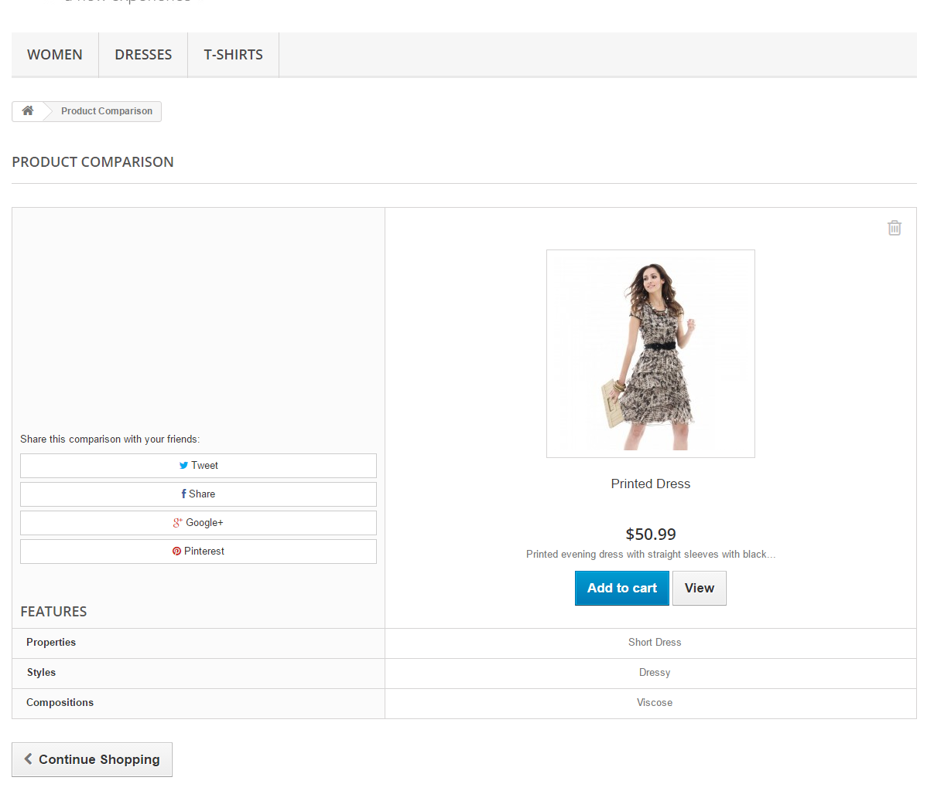

* Comparing 4 products

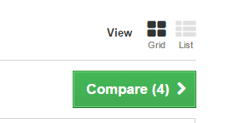

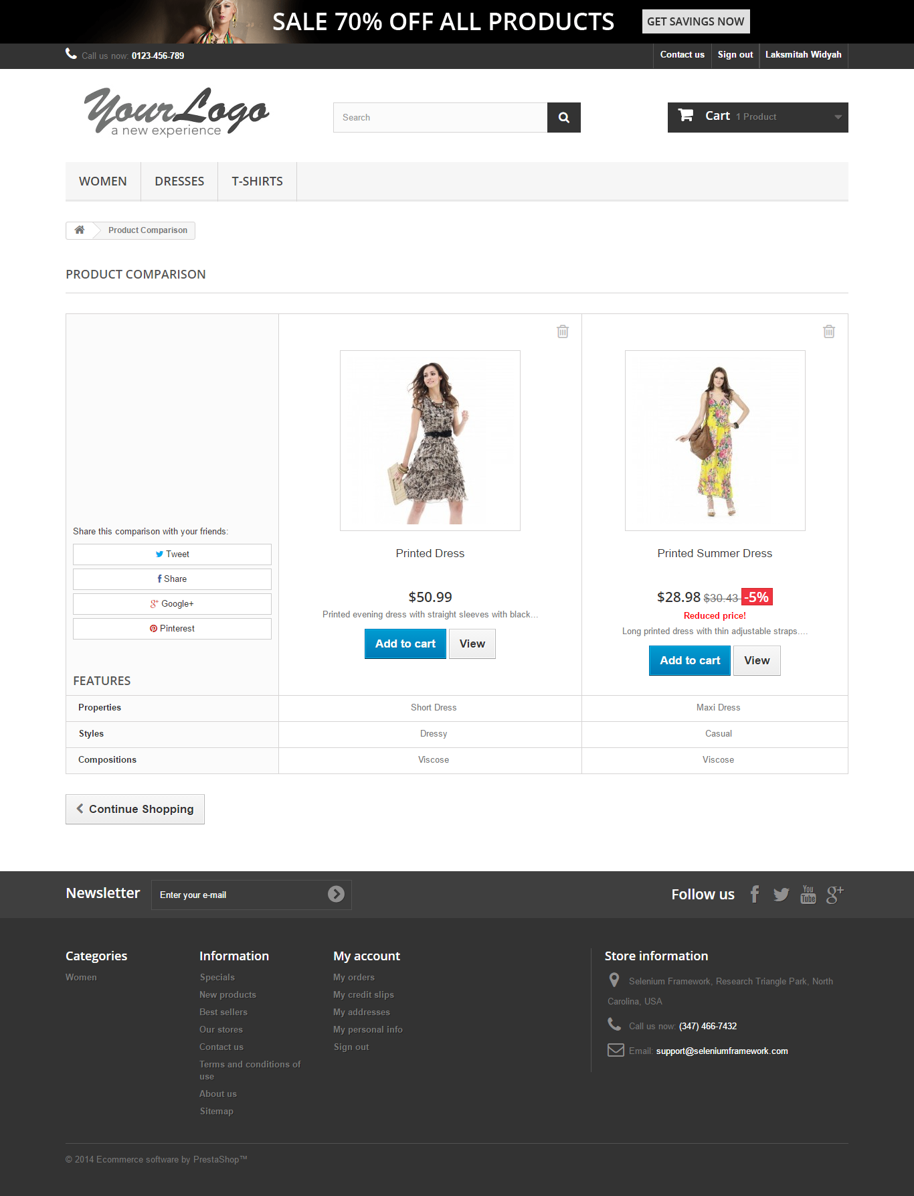

* + #12 [Product Profile More Detail] Product summary could not be sent to email address

**Environment :**

Device : Lenovo Laptop

OS : Windows 8

Browser : Chrome Version 57.0.2987.110 (64-bit)

**Types of Severity:** High

**Steps to Reproduce:**

1. Navigate to <http://automationpractice.com/>
2. Click one of categories on menu bar i.e : “Dresses” menu
3. Hover one of the product
4. Click More button on product list/grid view
5. Click send to friend button
6. Input value :

* Name of your friend data: valid and not empty
* Email address of your friend: valid and not empty

1. Click send button

**Expected Result** : Product is successfully send to friend’s email

**Actual Result :** Failed send to friend’s email

**Attachment:**

